Triangular Antiprism
# Source: AI Source: Provided by: [Data Path: Persons Table -> ID Column: 1, Name_En Column: Motasem Essam] -> From: [ChatGPT] on [7/25/2026]
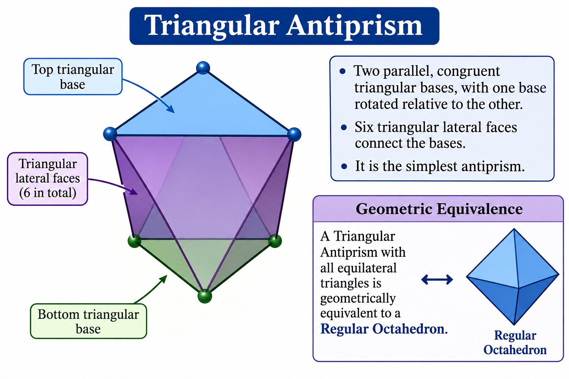

Definition
# Source: AI Source: Provided by: [Data Path: Persons Table -> ID Column: 1, Name_En Column: Motasem Essam] -> From: [ChatGPT] on [7/25/2026]
A Triangular Antiprism is a polyhedron consisting of two parallel, congruent triangular bases, with one base rotated relative to the other, and six triangular lateral faces connecting the bases.
It is the simplest antiprism and is geometrically equivalent to a Regular Octahedron when all its faces are equilateral triangles.
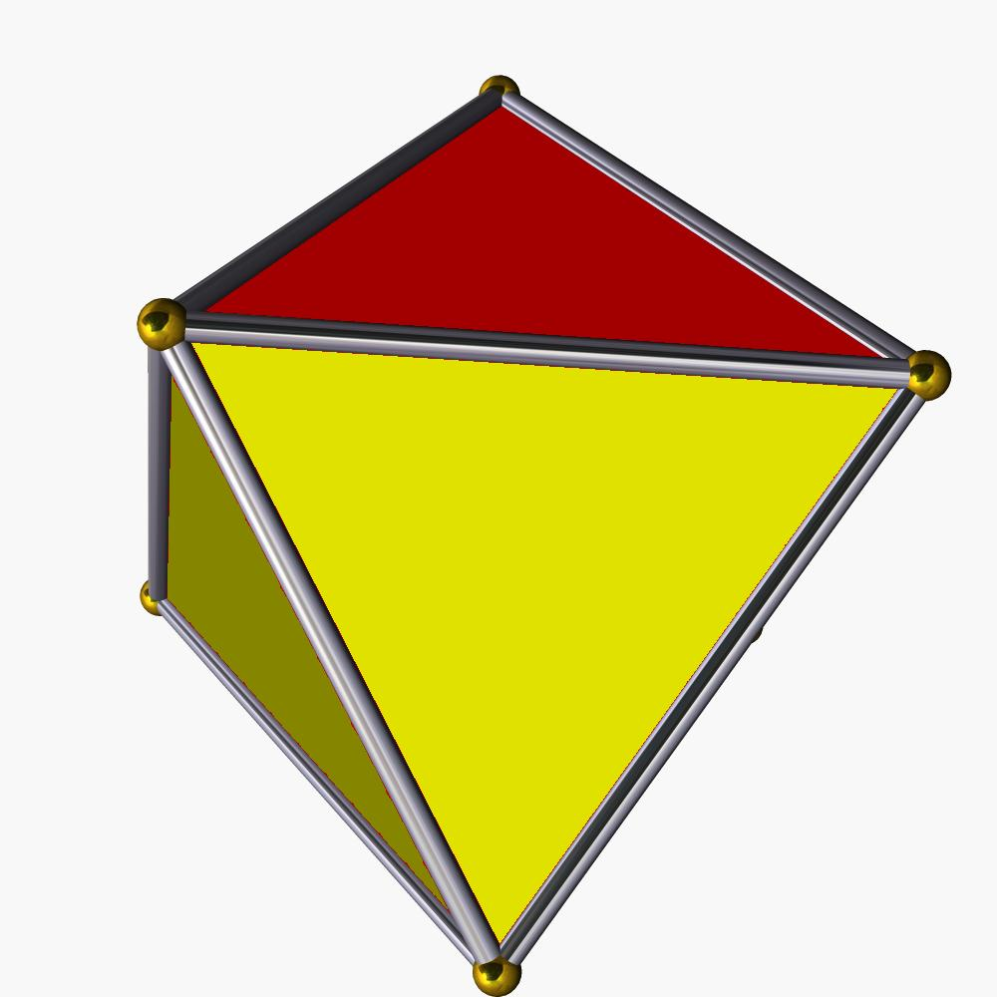

Geometric Structure
# Source: AI Source: Provided by: [Data Path: Persons Table -> ID Column: 1, Name_En Column: Motasem Essam] -> From: [ChatGPT] on [7/25/2026]
The triangular antiprism consists of:
- Upper Base: One equilateral triangular face.
- Lower Base: A congruent equilateral triangular face, rotated relative to the upper base.
- Triangular Lateral Faces: Six triangles connecting the two bases.
- Vertices: Six vertices, three on each base.
- Edges: Twelve edges forming the boundaries of the eight triangular faces.
The upper and lower triangular bases are parallel, and their vertices are arranged alternately when viewed along the axis of the solid.

Face Composition
# Source: AI Source: Provided by: [Data Path: Persons Table -> ID Column: 1, Name_En Column: Motasem Essam] -> From: [ChatGPT] on [7/25/2026]
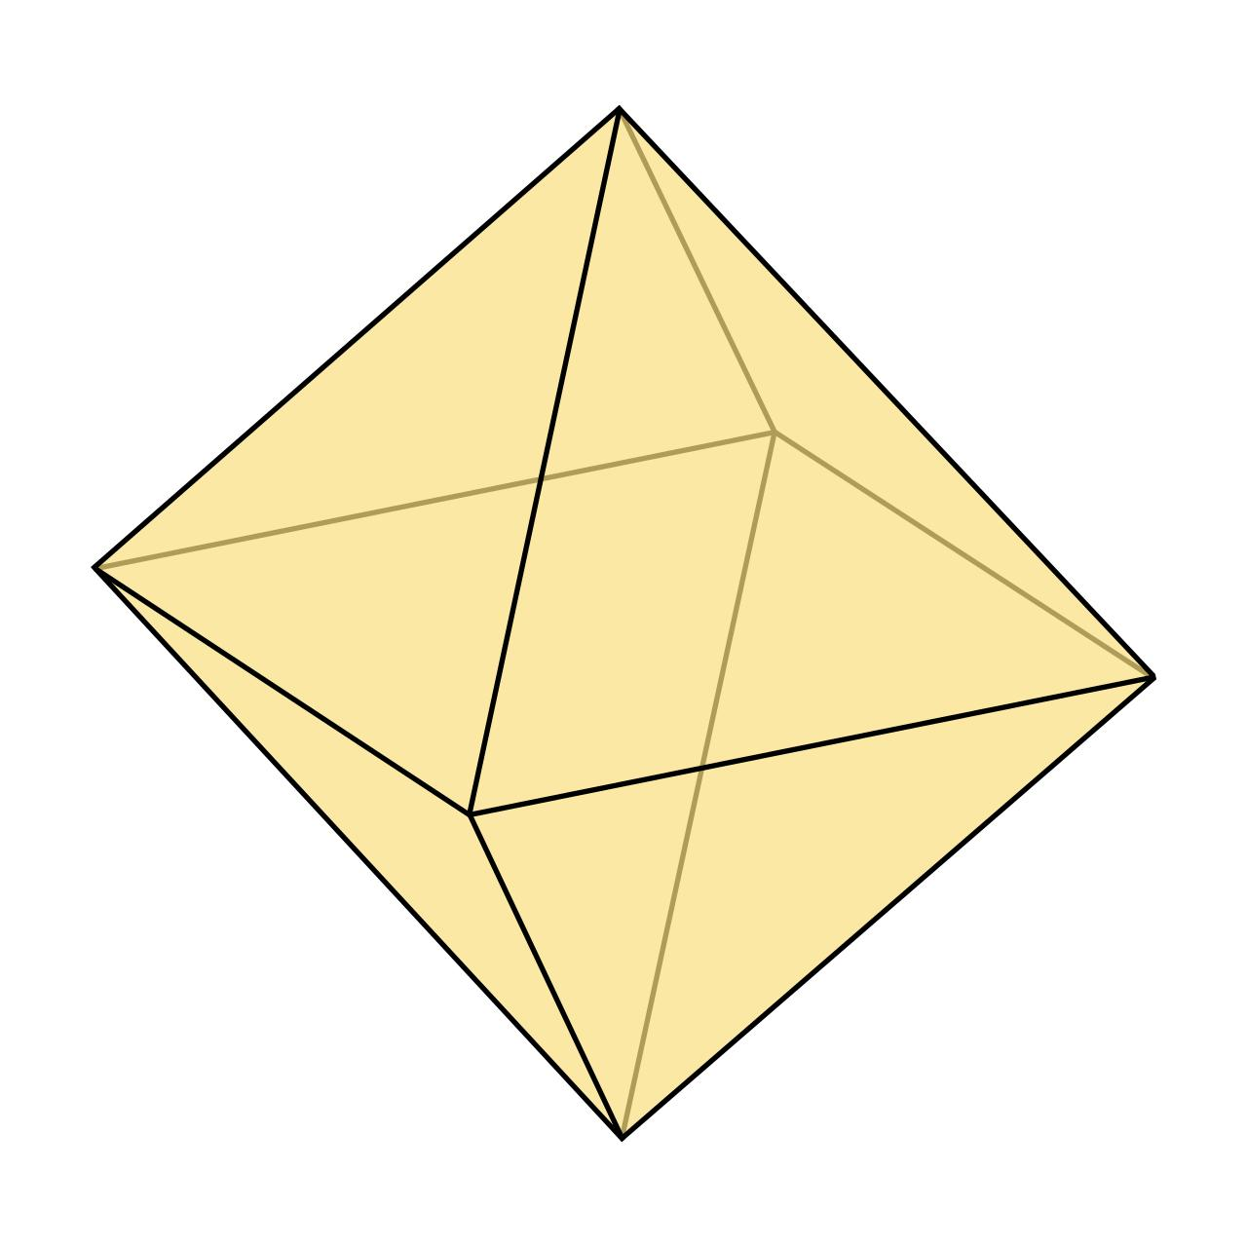

Upper Triangular Base
# Source: AI Source: Provided by: [Data Path: Persons Table -> ID Column: 1, Name_En Column: Motasem Essam] -> From: [ChatGPT] on [7/25/2026]
An equilateral triangular face forming the top base.
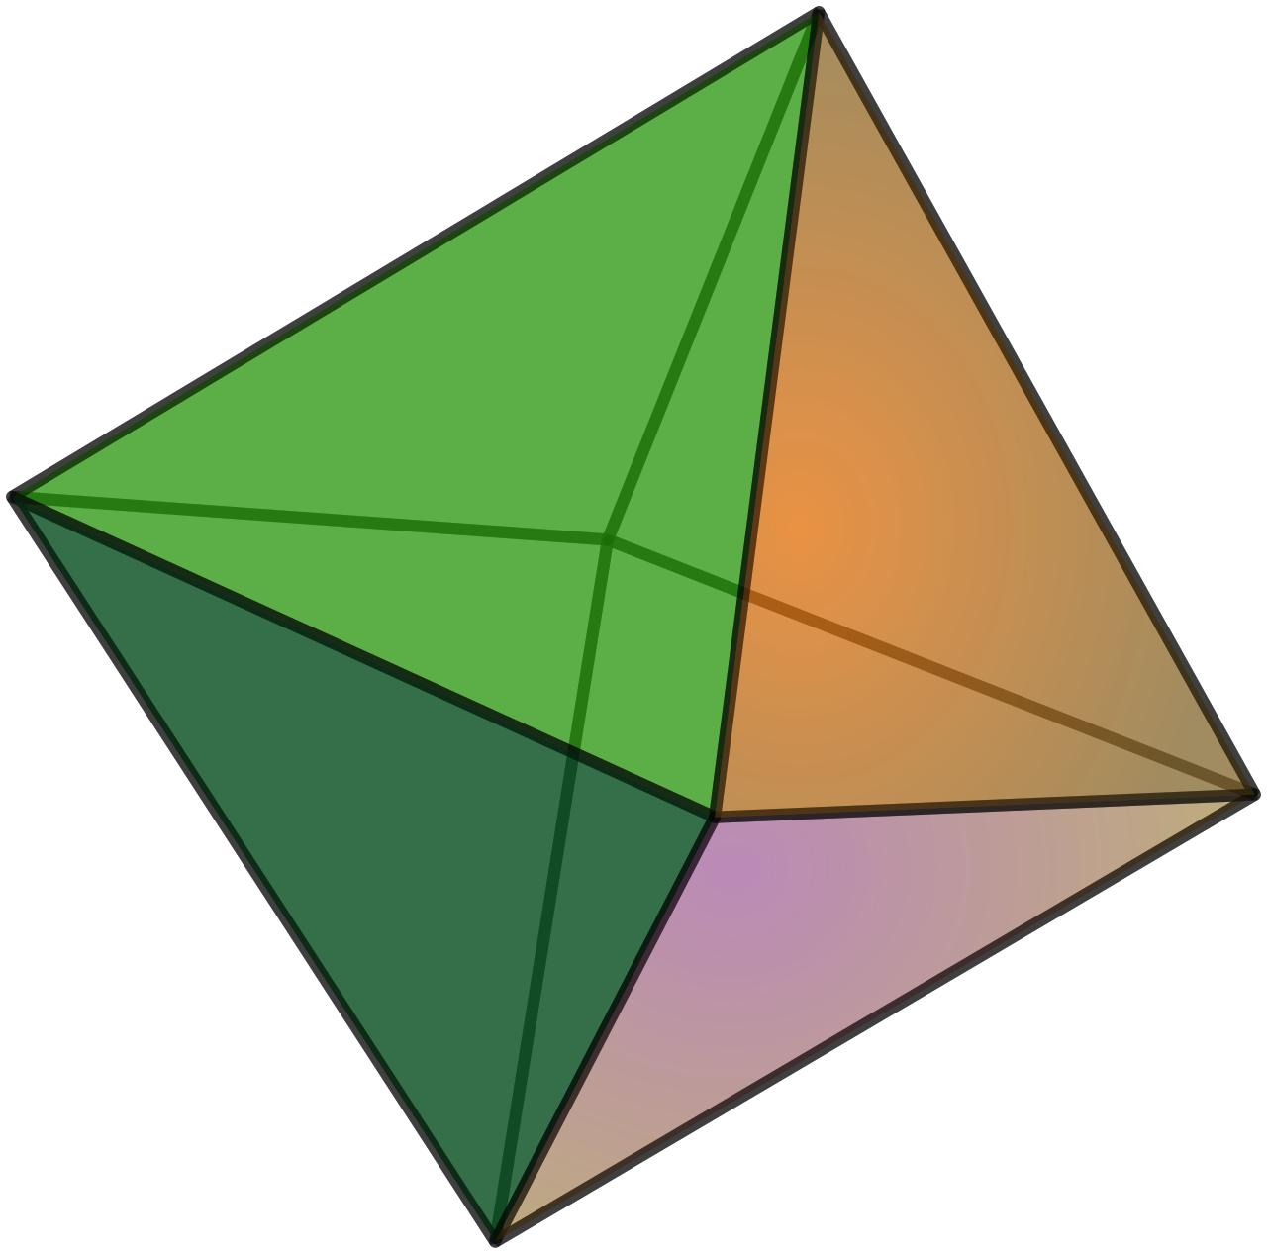

Lower Triangular Base
# Source: AI Source: Provided by: [Data Path: Persons Table -> ID Column: 1, Name_En Column: Motasem Essam] -> From: [ChatGPT] on [7/25/2026]
A congruent equilateral triangular face forming the bottom base.

Triangular Lateral Faces
# Source: AI Source: Provided by: [Data Path: Persons Table -> ID Column: 1, Name_En Column: Motasem Essam] -> From: [ChatGPT] on [7/25/2026]
Triangular faces connecting the upper and lower bases.
Total face composition:
- 2 Triangular Bases.
- 6 Triangular Lateral Faces.
- 8 Triangular Faces in total.

Mathematical Properties
# Source: AI Source: Provided by: [Data Path: Persons Table -> ID Column: 1, Name_En Column: Motasem Essam] -> From: [ChatGPT] on [7/25/2026]
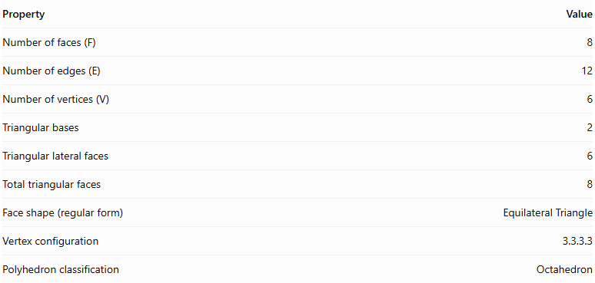
Property | Value
Number of faces (F) | 8
Number of edges (E) | 12
Number of vertices (V) | 6
Triangular bases | 2
Triangular lateral faces | 6
Total triangular faces | 8
Face shape (regular form) | Equilateral Triangle
Vertex configuration | 3.3.3.3
Polyhedron classification | Octahedron
Euler's Formula
$$V-E+F=2$$
$$6-12+8=2$$
Regular Triangular Antiprism Properties
When all eight triangular faces are equilateral, the triangular antiprism is a regular octahedron.
For edge length $a$:
Surface Area
$$A=2\sqrt{3}a^{2}$$
Volume
$$V=\frac{\sqrt{2}}{3}a^{3}$$

Constructing Triangular Antiprism in Solid Geometry

Geometric Instruments Used
# Source: AI Source: Provided by: [Data Path: Persons Table -> ID Column: 1, Name_En Column: Motasem Essam] -> From: [ChatGPT] on [7/25/2026]
The construction uses traditional geometric instruments rather than coordinate-based construction.
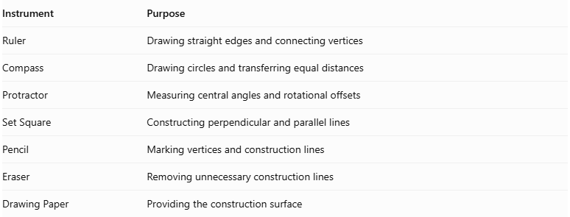
Instrument | Purpose
Ruler | Drawing straight edges and connecting vertices
Compass | Drawing circles and transferring equal distances
Protractor | Measuring central angles and rotational offsets
Set Square | Constructing perpendicular and parallel lines
Pencil | Marking vertices and construction lines
Eraser | Removing unnecessary construction lines
Drawing Paper | Providing the construction surface

Instrument-Based Construction Procedures

Constructing the Lower Triangular Base
# Source: AI Source: Provided by: [Data Path: Persons Table -> ID Column: 1, Name_En Column: Motasem Essam] -> From: [ChatGPT] on [7/25/2026]
- Draw a circle using a compass.
- Mark its center.
- Divide the circumference into three equal angular sections using a protractor.
- Each central angle measures:
$$\frac{{360}^{∘}}{3}={120}^{∘}$$
- Mark the three points around the circumference.
- Connect consecutive points using a ruler.
- Complete the regular equilateral triangular base.

Constructing the Upper Triangular Base
# Source: AI Source: Provided by: [Data Path: Persons Table -> ID Column: 1, Name_En Column: Motasem Essam] -> From: [ChatGPT] on [7/25/2026]
- Draw a second congruent equilateral triangle above the lower base.
- Keep the two base planes parallel.
- Rotate the upper triangle by ${60}^{∘}$ relative to the lower triangle.
- Ensure that both triangular bases have equal side lengths.
- Maintain the required perpendicular separation between the two base planes.

Connecting the Two Bases
# Source: AI Source: Provided by: [Data Path: Persons Table -> ID Column: 1, Name_En Column: Motasem Essam] -> From: [ChatGPT] on [7/25/2026]
- Connect the first upper-base vertex to two neighboring lower-base vertices.
- Repeat the alternating connections for the remaining upper-base vertices.
- Connect each lower-base vertex to its two neighboring upper-base vertices.
- Form six triangular lateral faces.
- Check that the triangular faces form a continuous band around the solid.

Completing the Antiprism
# Source: AI Source: Provided by: [Data Path: Persons Table -> ID Column: 1, Name_En Column: Motasem Essam] -> From: [ChatGPT] on [7/25/2026]
- Verify that both triangular bases are congruent and parallel.
- Check the ${60}^{∘}$ rotational offset.
- Darken the visible external edges.
- Represent hidden edges using dashed lines when necessary.
- Remove unnecessary construction marks.
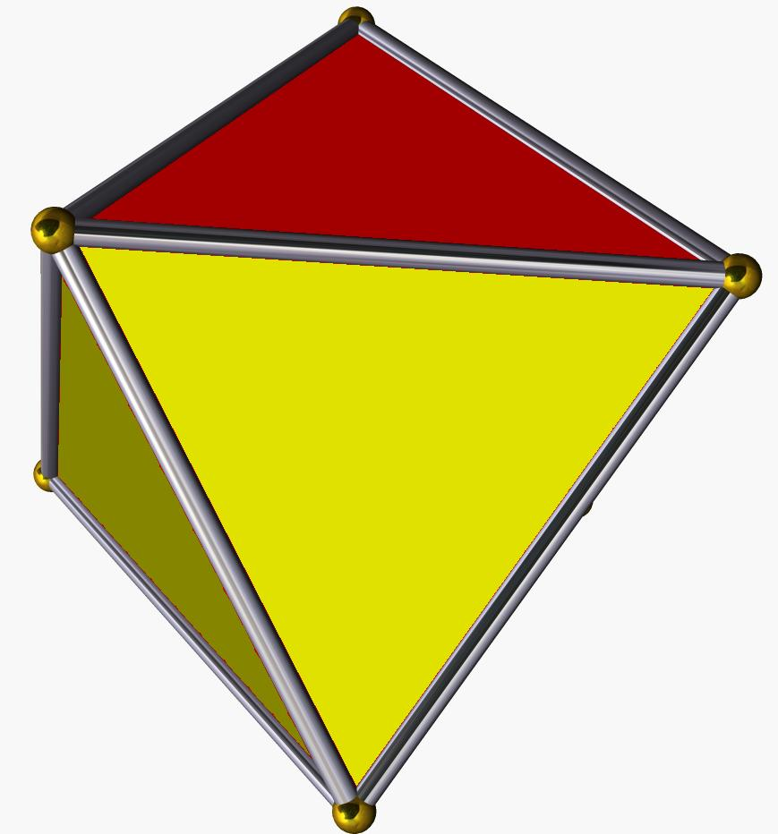

Key Points
# Source: AI Source: Provided by: [Data Path: Persons Table -> ID Column: 1, Name_En Column: Motasem Essam] -> From: [ChatGPT] on [7/25/2026]
- It is the simplest type of antiprism.
- It has two parallel, congruent triangular bases.
- The bases are rotated relative to each other.
- It has six triangular lateral faces.
- It contains 8 faces, 12 edges, and 6 vertices.
- All eight faces are equilateral triangles in its regular form.
- Its regular form is geometrically identical to a regular octahedron.
- It has four triangular faces meeting at each vertex.

Conclusion
# Source: AI Source: Provided by: [Data Path: Persons Table -> ID Column: 1, Name_En Column: Motasem Essam] -> From: [ChatGPT] on [7/25/2026]
The Triangular Antiprism is an antiprism with two parallel, congruent triangular bases connected by six triangular lateral faces. It consists of 8 triangular faces, 12 edges, and 6 vertices. When all faces are equilateral triangles, it forms a regular octahedron.

